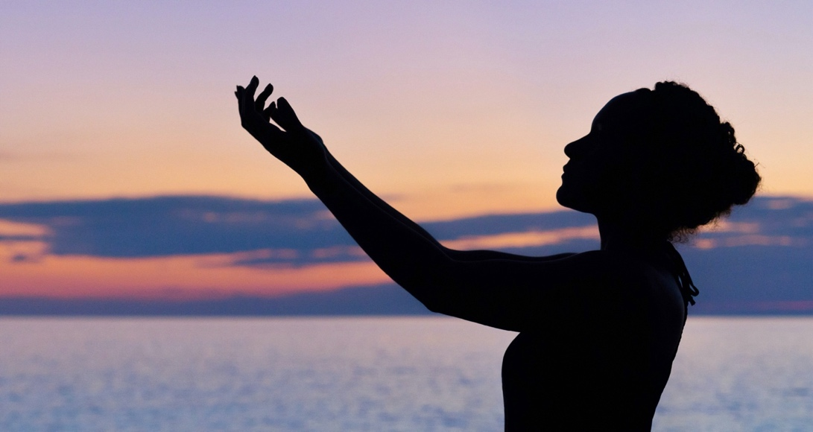
What are Your Unique Gifts?
How Reiki Helps Us
Develop and Express Them
With Maureen Pua’ena O’Shaughnessy, Reiki Master
Sunday December 7
9:00 am Hawaii
2:00 pm Eastern
20:00 pm CET

We are all born with unique, innate gifts. Many of us are unaware of our gifts. I have found in my own life as well and many of my students’ experiences, that regular practice of Reiki can effortlessly nurture these gifts and allow them to blossom.

During this webinar we will discuss why not everyone is aware of their gifts and what helps us connect and express them.

There will be some specific tools, examples and stories as well as time for discussion. For those interested, I will, from my Intuitive state, help you identify some of your own unique gifts.

Please bring your own experiences, questions and curiosity to this uplifting and inspiring webinar!

Maureen is originally from Canada and has lived in Hawaii for over 45 years. She is passionate about Reiki as it transformed her life to one of great fulfillment. She has been teaching Reiki in Hawaii (and many other places) since 1995. She has been a member of The Reiki Alliance since 1997, and this has blessed her with being able to travel and learn with other Reiki Masters around the world.

Reiki has nourished other gifts in Maureen, including her unique intuitive abilities, which she shares with clients as well as Reiki.

